**LAB SESSION 10**

**OBSERVATION**

Two atmega162 AVR kits are used, first kit works as transmitter which sends bit by bit data serially through port A0 which is received by the second kit which acts as a receiver. Whenever we push button, data is send and received by receiver which checks data with saved pattern, if it matches then an led toggle.

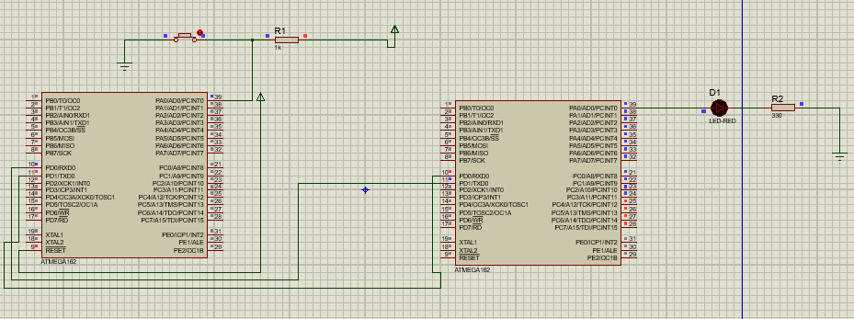

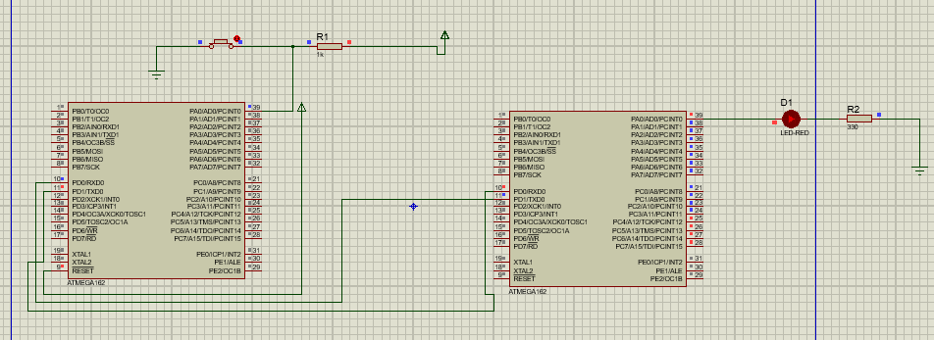

Exercise

**1. Explore Baud rate. Give value loaded in the baud rate register to set the desired baud rate. Explore the usage of U2X bit in USCRA register.**

The baud rate is the rate at which information is transferred in a communication channel

UBRR= (fosc/16*BAUD)-1

U2X bit in USCRA register is used to double the speed of transfer

UBRR= (fosc/8*BAUD)-1

**2. With 1 MHz input clock for 9600 Baud rate give the required baud value.**

Baud Value = ((1000000/(9600*16)) – 1)

= ((1000000/153600) – 1 )

= (6.510 – 1)

= 5.51

Baud Value ~ 6

**3. Design an algorithm to show steps of transmission and reception of data**

Transmission

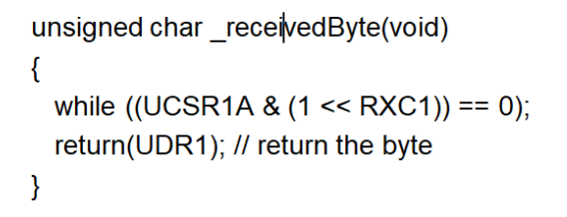

Reception

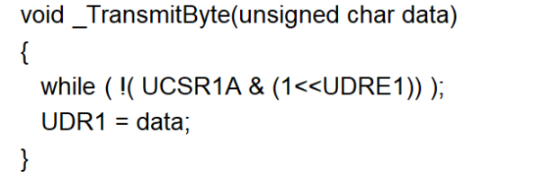

**4. Write a piece of code to send a stream over USART and receive the transmitted data and display on LEDs.**

